**Lab 2 Group**

Case 1: 100kHz (Alexis)

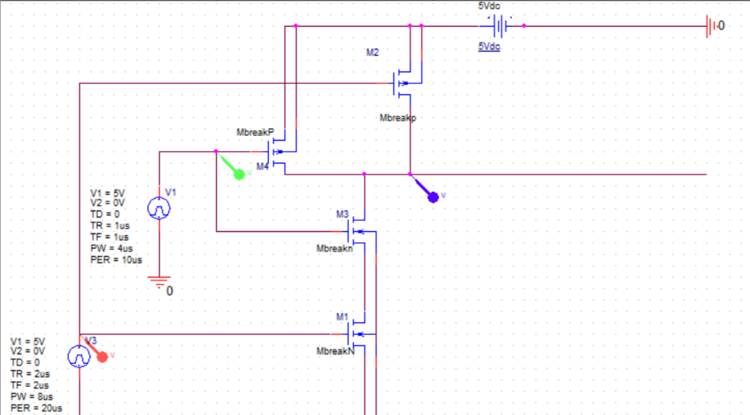

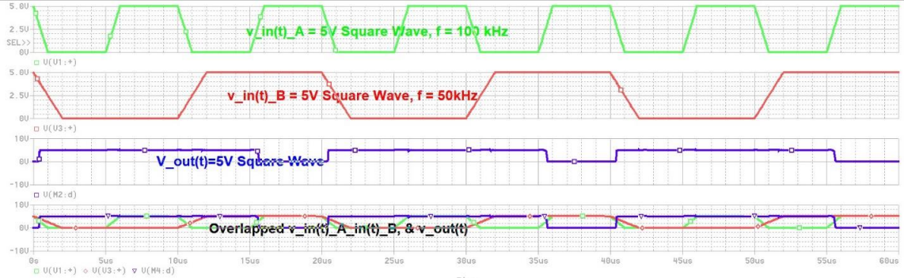

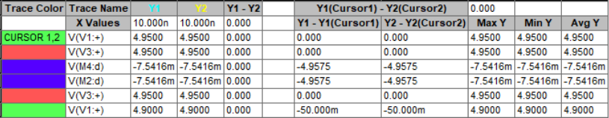

Case 1: 200kHz (Sungmin)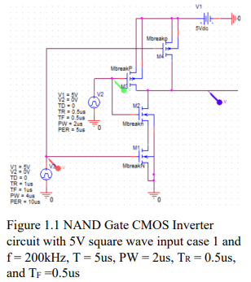

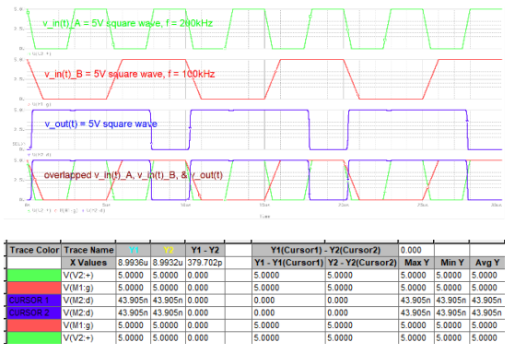

Figure 1.2 NAND Gate with I/p A & B – O/p Waveform of the CMOS Inverter circuit with 5V square wave input case 1 and f = 200kHz T = 5us, PW = 2us, TR = 0-.5us, and TF =0.5us

Case 2: 300kHz (Haroutun)

Figure 2.1: Circuit Schematic for 5V squarewave, f = 300kHz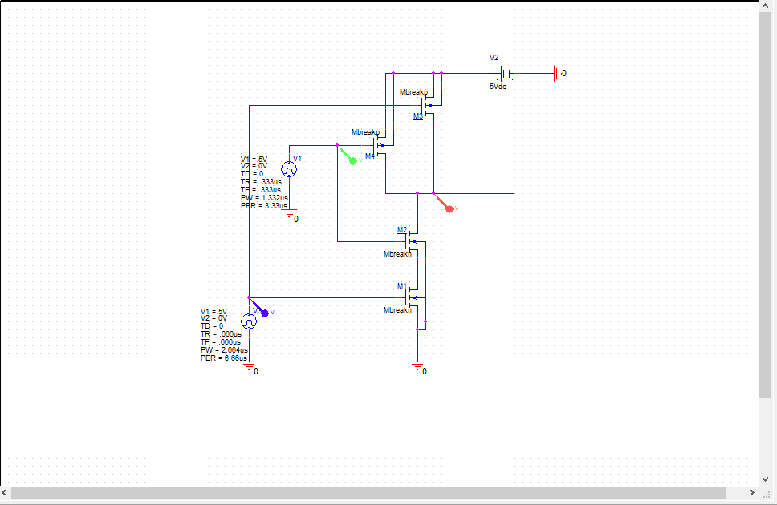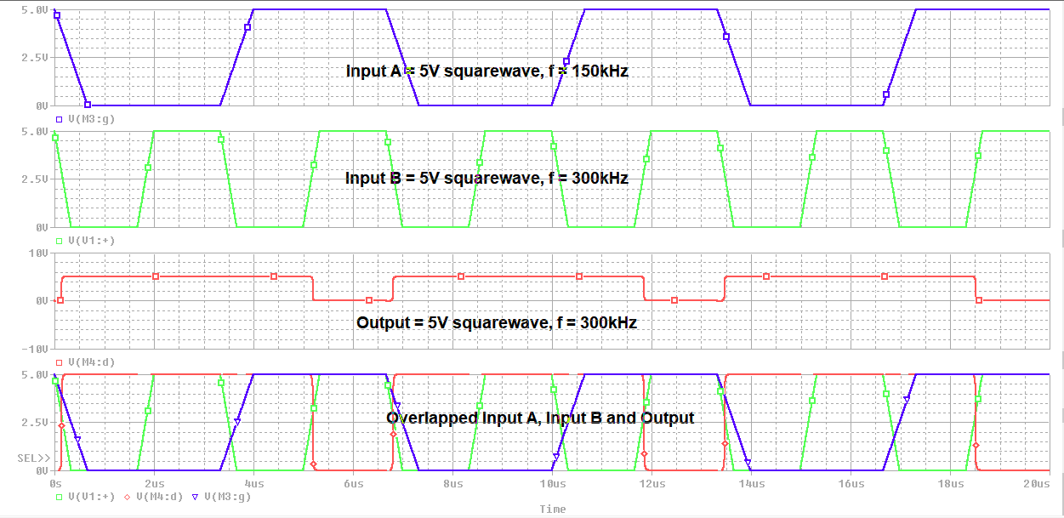

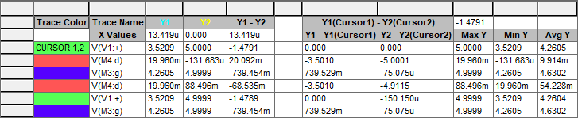

Figure 2.2: Output waveform for 5V squarewave, f = 300kHz

Case 3: 600kHz (Alexis)

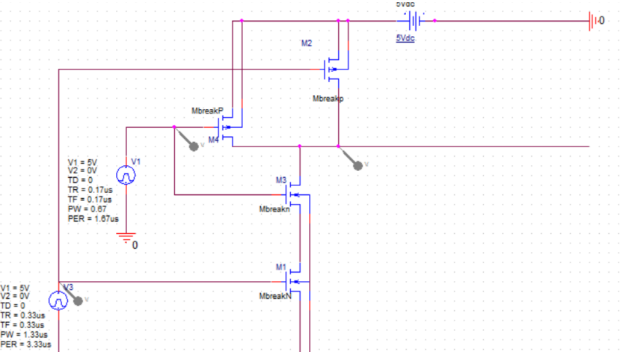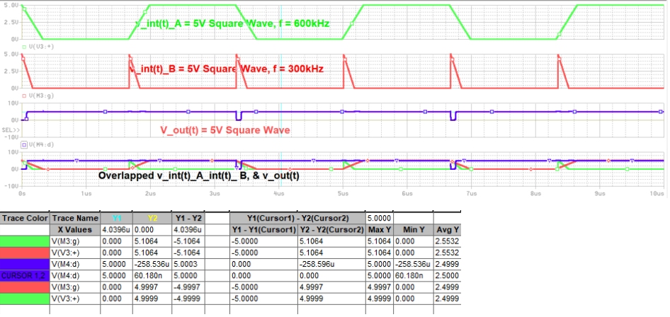

Case 3: 800kHz (Sungmin)

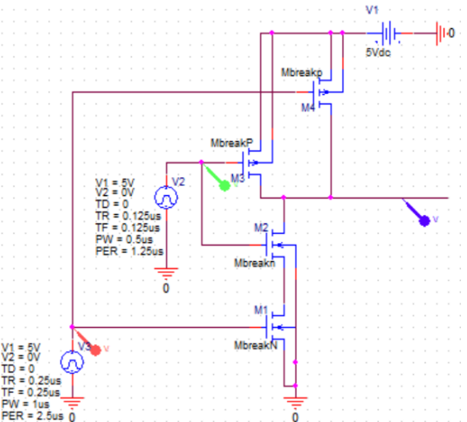

Figure 3.1: NAND Gate CMOS Inverter circuit with 5V square wave input case 3 and f = 800kHz, T = 1.25us, PW = 0.5us, TR = 0.125us, and TF =0.125us

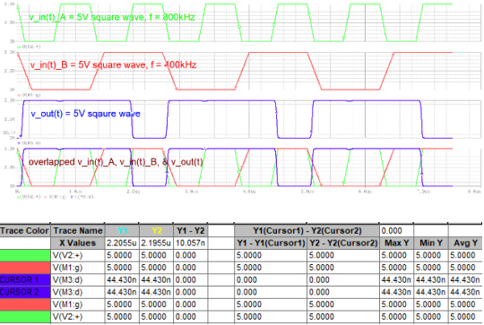

Figure 3.2: NAND Gate with I/p A & B – O/p Waveform of the CMOS Inverter circuit with 5V square wave input case 3 and f = 800kHz, T = 1.25us, PW = 0.5us, TR = 0.125us, and TF =0.125us

Case 4: 900kHz (Haroutun)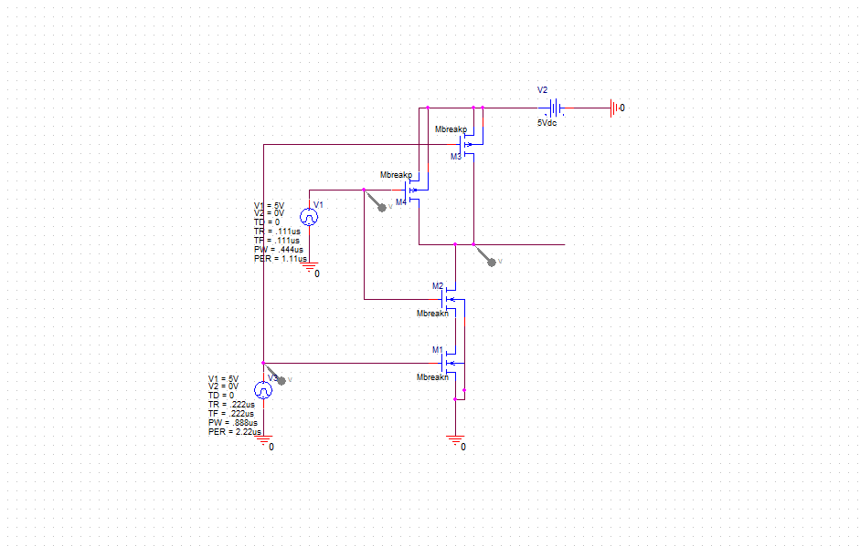

Figure 4: Circuit Schematic for 5V squarewave, f = 900kHz

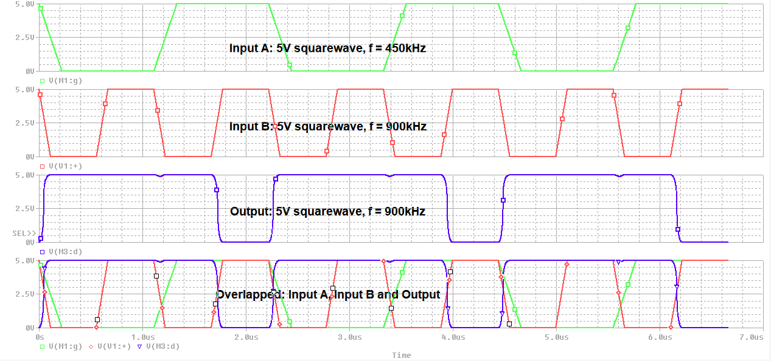

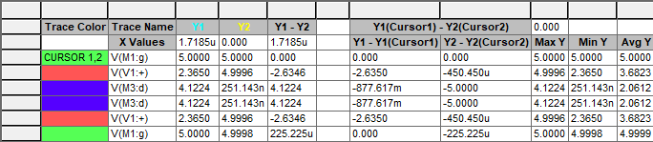

Figure 4.2: Output waveform for 5V squarewave, f = 900kHz

Ramp Case 1: 100kHz (Alexis)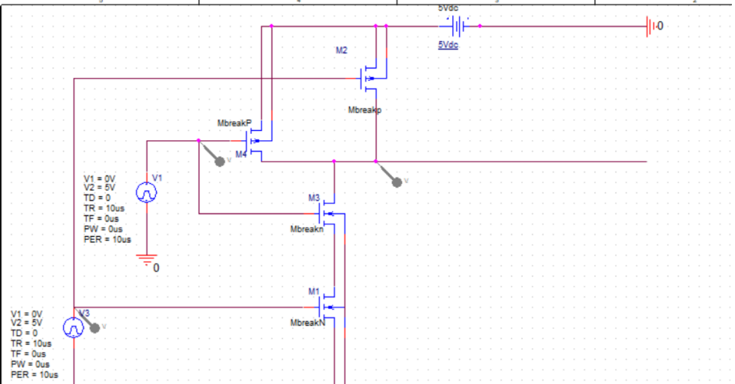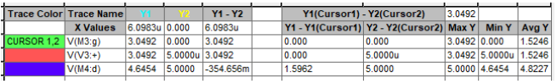

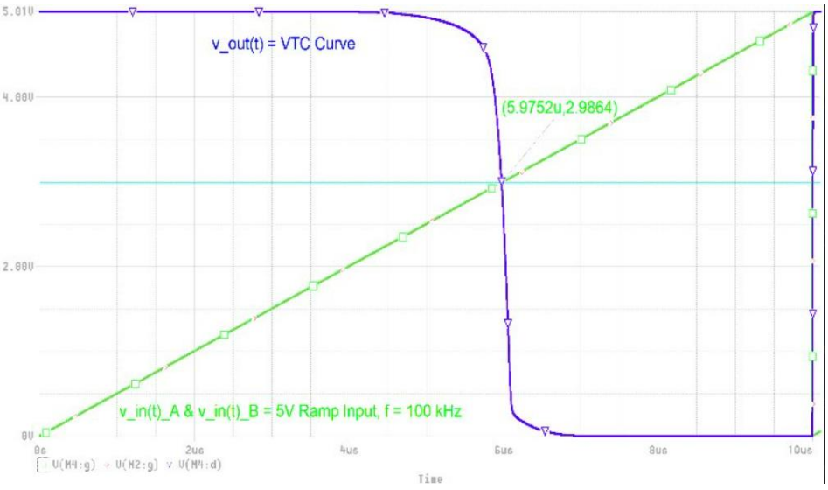

Ramp Case 1: 100kHz (Sungmin)

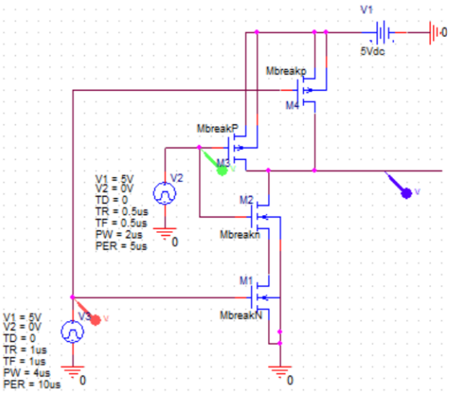

Figure 5.1: NAND Gate CMOS Inverter 5V Ramp wave input case 1 for f = 100kHz

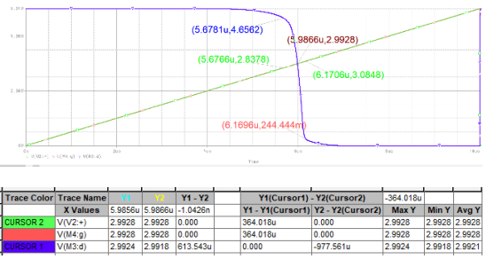

Figure 5.2: Zoomed NAND Gate CMOS Inverter I/p – O/p voltage transfer characteristics curve for 5V Ramp case 1, f = 100kHz with normal width and length of NMOS and PMOS

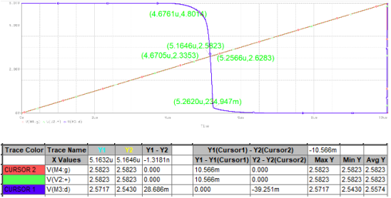

Figure 5.3: Zoomed CMOS Inverter I/p – O/p voltage transfer characteristics curve for 5V Ramp case 1, f = 100kHz with increased NMOS width from 30um to 450um

Ramp Case 2: 200kHz (Haroutun)

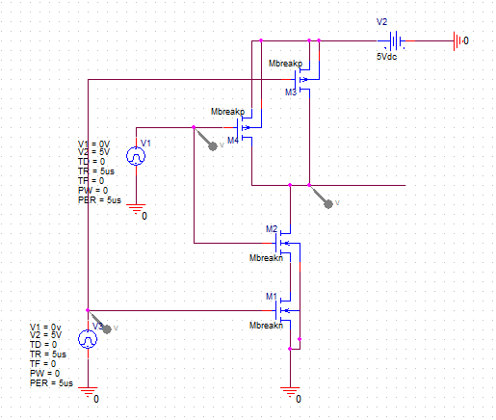

Figure 6.1: Circuit Schematic for 5V Ramp Case, f = 200kHz

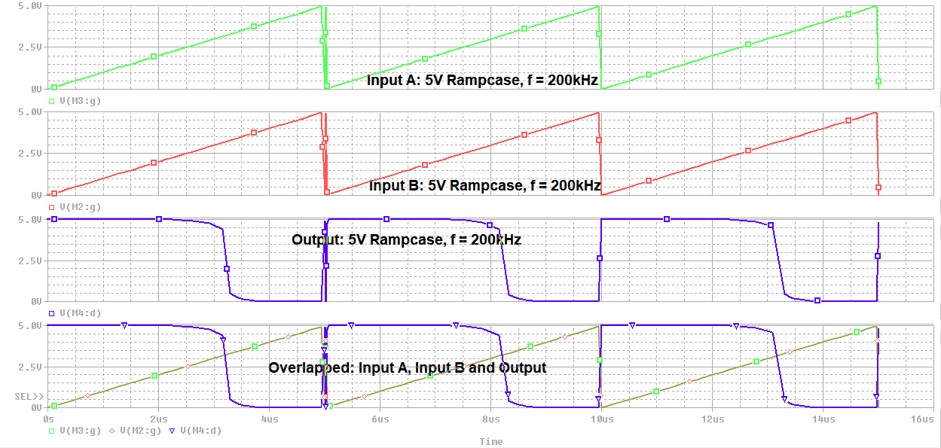

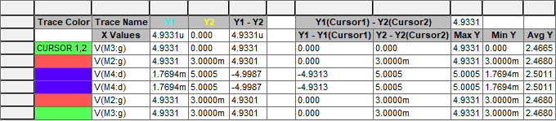

Figure 6.2: Output waveform for 5V Ramp case, f = 200kHz

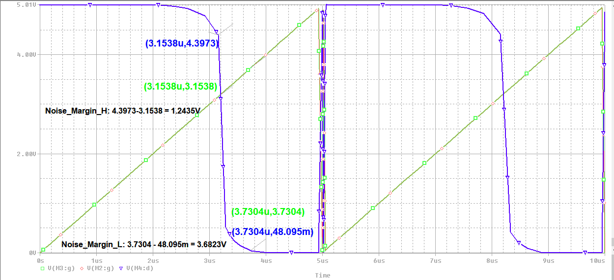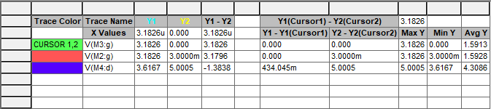

Figure 6.3: Noise Margin waveform for ramp case, f = 200kHz